Unit 1:

Example:

Player has no lives THEN Game is over.

|  |  |
| --- | --- |
| Player has no lives | Games is over |
| False | False |
| True | True |

Activity

It is raining THEN Open umbrella.

|  |  |
| --- | --- |
| It is raining | Open Umbrella |
| False | False |
| True | True |

Activity:

Cake is cooked THEN Remove cake from oven.

|  |  |
| --- | --- |
| Cake is cooked | Remove cake from oven |
| False | False |
| True | True |

Using AND to link Logical Statement

Player is left-footed **AND** Player scored 30 goals THEN Club signs player.

|  |  |  |
| --- | --- | --- |
| Player is left-footed | Player scored 30 goals | Club signs player |
| False | False | False |
| False | True | False |
| True | False | False |
| True | True | True |

Activity:

Vase is blue AND Cost is not more than $5 THEN Buy the blue vase.

|  |  |  |
| --- | --- | --- |
| Vase is blue | Cost is not more than $5 | Buy the blue vase |
| False | False | False |
| False | True | False |
| True | False | False |
| True | True | True |

Smoke sensor is triggered OR Heat sensor is triggered THEN An alarm must sound.

|  |  |  |
| --- | --- | --- |
| Smoke sensor is triggered | Heat sensor is triggered | An alarm must sound |
| FALSE | FALSE | FALSE |
| FALSE | TRUE | TRUE |
| TRUE | FALSE | TRUE |
| TRUE | TRUE | TRUE |

Extra challenge

A Key turned in a lock AND Personal pin number entered AND the alarm turned off THEN Open the safe

|  |  |  |  |
| --- | --- | --- | --- |
| A Key turned in a lock | Personal pin number entered | the alarm turned off | Open the safe |
| FALSE | FALSE | FALSE | FALSE |
| FALSE | FALSE | TRUE | FALSE |
| FALSE | TRUE | FALSE | FALSE |
| FALSE | TRUE | TRUE | FALSE |
| TRUE | FALSE | FALSE | FALSE |
| TRUE | FALSE | TRUE | FALSE |
| TRUE | TRUE | FALSE | FALSE |
| TRUE | TRUE | TRUE | TRUE |

Logic Gates

**The AND Gate**

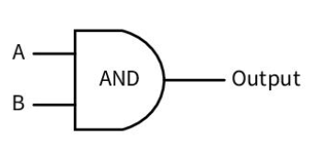

|  |  |  |
| --- | --- | --- |
| A | B | Output |
| 0 | 0 | 0 |
| 0 | 1 | 0 |
| 1 | 0 | 0 |
| 1 | 1 | 1 |

**The OR Gate**

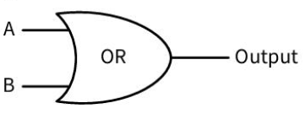

|  |  |  |
| --- | --- | --- |
| A | B | Output |
| 0 | 0 | 0 |
| 0 | 1 | 1 |
| 1 | 0 | 1 |
| 1 | 1 | 1 |

**The NOT Gate**

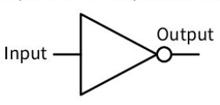

|  |  |
| --- | --- |
| Input | Output |
| 0 | 1 |
| 1 | 0 |

**Circuits**

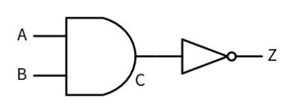

|  |  |  |  |
| --- | --- | --- | --- |
| **A** | **B** | **C** | **Z** |
| 0 | 0 | 0 | 1 |
| 0 | 1 | 0 | 1 |
| 1 | 0 | 0 | 1 |
| 1 | 1 | 1 | 0 |

Activity

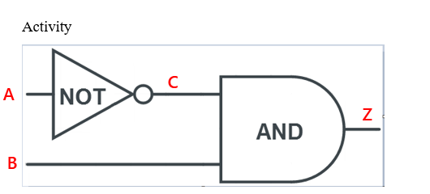

Truth Table

|  |  |  |  |
| --- | --- | --- | --- |
| A | C | B | Z |
| 0 | 1 | 0 | 0 |
| 0 | 1 | 1 | 1 |
| 1 | 0 | 0 | 0 |
| 1 | 0 | 1 | 0 |

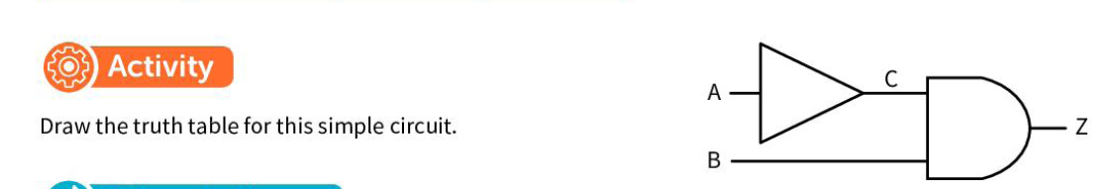

Truth Table

|  |  |  |  |
| --- | --- | --- | --- |
| A | C | B | Z |
| 0 | 0 | 0 | 0 |
| 0 | 0 | 1 | 0 |
| 1 | 1 | 0 | 0 |
| 1 | 1 | 1 | 1 |

Exercise

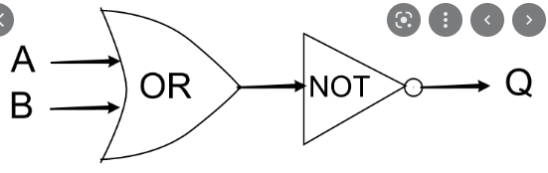

|  |  |  |  |
| --- | --- | --- | --- |
| A | B | C | Q |
| 0 | 0 | 0 | 1 |
| 0 | 1 | 1 | 0 |
| 1 | 0 | 1 | 0 |
| 1 | 1 | 1 | 0 |